Coursera: Introduction to Programming with MATLAB.

Week 7 : Lesson 6 : Loops

For Loop:

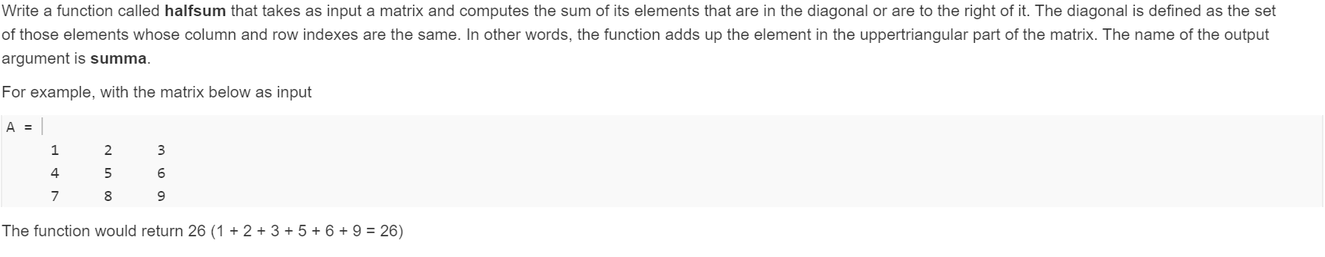

Ans:

function summa = halfsum(A)

[row col] = size(A);

summa =0;

for r=1:row

for c=1:col

if r<=c

summa = summa + A(r,c);

end

end

end

While loop

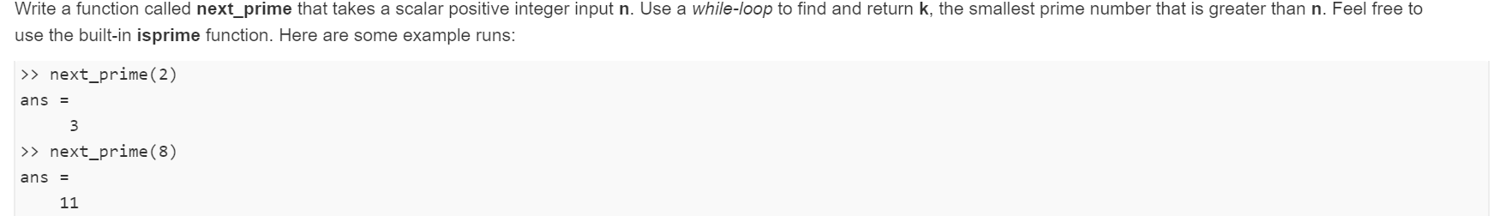

Ans:

function k = next_prime(n)

while ~isprime(n+1)

n=n+2;

end

k=n+1;

Logical Array

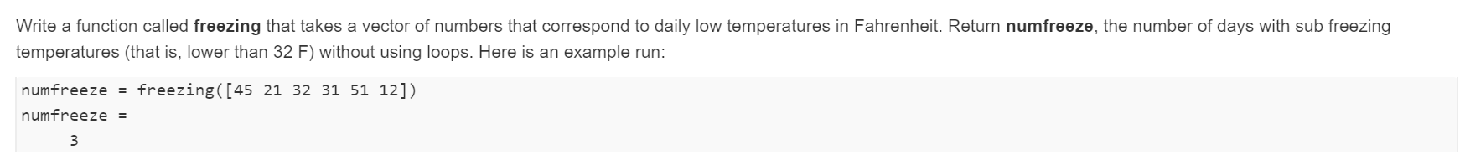

Ans:

function numfreeze = freezing(v)

num = v(v<32);

numfreeze = length(num);

Week 6 : Wrap up

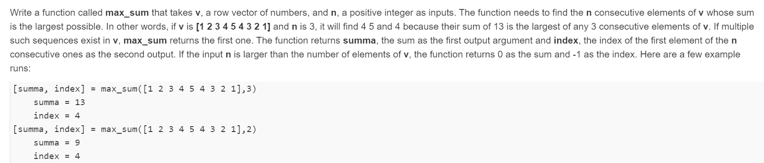

Ans:

function [summa, index]=max_sum(v,n)

if n>length(v)

summa=0;

index=-1;

return

end

summa = -inf;

index = -1;

for i= 1:length(v)-n+1

currentv=v(i:i+n-1);

currentsumma = sum(currentv);

if currentsumma > summa

summa = currentsumma;

index = i;

end

end

end